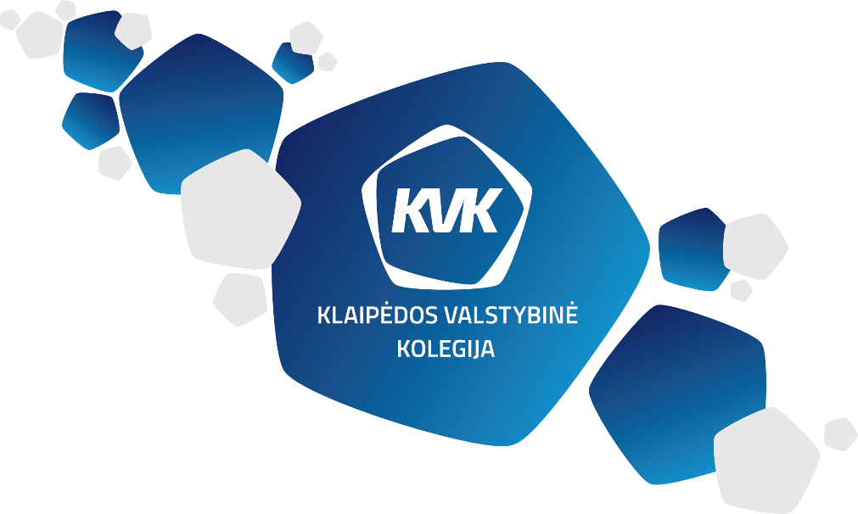

KLAIPEDOS VALSTYBINĖ KOLEGIJA / HIGHER EDUCATION INSTITUTION
FACULTY OF TECHNOLOGIES
DEPARTMENT OF ENVIRONMENTAL AND CONSTRUCTION ENGINEERING
INVITATION
On 10 April 2024, the Department of Environmental and Construction Engineering of Klaipėdos valstybinė kolegija / Higher Education Institution, Faculty of Technologies, together with TF mathematics lecturers, is organizing an International Exact Sciences Competition
"Know-Calculate-Memorize 2024"
Students are invited to participate in the competition while teachers are invited to share their experience and knowledge.
The competition will be held at Klaipėdos valstybinė kolegija / Higher Education Institution, Faculty of Technologies, 10 Bijūnu St., Klaipėda.
Competition Programme:
9⁰⁰-9³⁰ | Registration
9³⁰-10⁰⁰ | Opening and Welcome speech from the Director of Klaipedos valstybinė kolegija / Higher Education Institution. Welcoming speech from the Head of Department of Environmental and Construction Engineering. Brief information. (Room 212)
10¹⁵- 11⁴⁵ | Team problem-solving contest (Room 4th floor), and test on mathematics and physics knowledge. ( Classroom 220)
10¹⁵-11⁴⁵ | International seminar for teachers of exact sciences "Media Ecology and the Contemporary Teacher ". (Room 120)
11⁵⁰-12²⁰ | Coffee break. (Classroom 216)
12³⁰-14³⁰ | Bowling tournament for the competition cup. ("Acropolis" of Klaipeda)
14⁴⁰-15⁰⁰ | Announcement of competition results and awarding the winners. (Classroom 216)
Areas (topics) of the test and practical tasks :
Fundamentals of general physics: Laws of mechanics, molecular physics and thermodynamics, direct and alternating current, and light propagation.
Areas of mathematics: Linear algebra (matrices, determinants, solution of systems of linear equations by inverse matrices, methods of Cramer, Gauss, Jordan - Gauss), vector algebra (operations with vectors, multiplications), limits, derivatives of composite functions, partial derivatives, indefinite and definite integrals and their application.
Deadline for registration to the competition is 28 March 2024
Registration link: https://forms.office.com/e/3H9CidMwwh
The team shall consist of four students.
Contact persons: r.sudziuviene@kvk.lt v.jakubauskiene@kvk.lt
The event is sponsored by: MB ,,Georaida“ ir www.kvk.lt

